Assessment Schedule – 2016

Physics: Demonstrate understanding electrical systems (91526)

Evidence Statement

NØ | N1 | N 2 | A 3 | A 4 | M 5 | M 6 | E 7 | E 8
0 | 1A | 2A | 3A | 4A or 2A + M | 3A + M or A +2M | 3M or 2A + 2M | A + M + E | A + 2M +E
A = 1, M = 2, E = 3
Q | Evidence | Achievement | Merit | Excellence
ONE  (a) | Q = CV = 2.20 × 10^{–6} × 5 = 1.10 × 10^{–5} C | Correct answer.
(b) | The maximum voltage is approximately 5.0 V.  The time constant is the time taken to reach 0.63 × 5.0 V (3.15 V).  This is approximately 1.1 s  OR  Estimates time constant correctly using 5 × τ = 5s  This is approximately 1.1 s  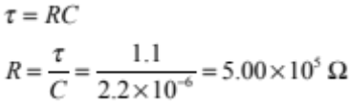  Allow variation due to reading off graph. | - Correct time constant.  - Correct working for R with incorrect time constant, uses 37% of V so  V = 1.85 and R = 2.27 × 10⁵. | - Correct answer.  R = 4.5 – 5.0 × 10⁵
(c) | 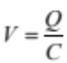  When the switch is first closed, the capacitor is uncharged, so the capacitor voltage starts at zero.  Electrons flow on to the capacitor fast initially (current is maximum) and so voltage rises rapidly.  (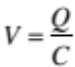 and C is constant)  As more and more charges accumulate on the plates, it will be harder for electrons to accumulate on the plates due to repulsive forces.  Electrons will then start flowing on to the capacitor more slowly (current decreases) and so voltage rises more slowly (less difference in potential between supply and capacitor).  When the capacitor is fully charged, the current is zero, the resistor voltage is zero so the capacitor voltage equals the battery voltage | - Correct explanation for the initial rate of change in voltage (I max therefore 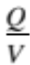 increases)  - Correct explanation for the rise in voltage.  - Q = CV, Q increases therefore V increases.  - Correct explanation for the final rate of change in voltage. | - Correct explanation for the initial voltage.  AND  Correct explanation for the rise in voltage.  OR  - Correct explanation for the rise in voltage.  AND  Correct explanation for the final voltage. | - All three concepts:  Initial, rise and final voltages.
(d) | The final voltage will be half the original voltage (OR V = 2.5 V) because the battery voltage is shared between two capacitors.  τ = RC and the total capacitance has decreased, so the time constant will decrease. | - New C = 1.1 × 10^{–6} F.  - Final voltage halved (2.5 V).  - Time constant decreases with reason. | Full explanation for both.

Q | Evidence | Achievement | Merit | Excellence
TWO  (a) | 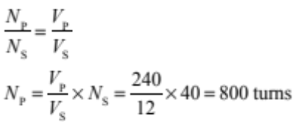 | Correct answer.
(b) | An alternating voltage across the primary causes…  An alternating current in the primary, which causes…  An alternating magnetic flux in the core, which causes…  An alternating voltage in the secondary, which causes…  A current in the lamp. | - Change in B / flux in primary.  - Induced V in secondary. | - Links the two points.
(c) | Graph as below.  When the switch closes, there is an increase in current.  This causes a back emf that opposes the current change.  This causes the current to rise gradually.  When the current reaches a maximum value, there is no flux change and no induced emf. The current is limited only by the resistance.  When the switch opens, there is an open circuit; this means the current must drop to zero (almost) instantaneously.  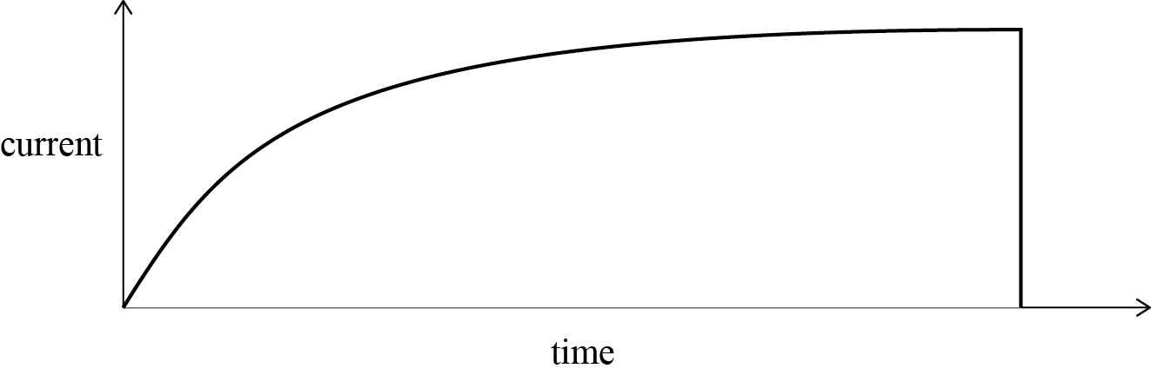 | - Graph correct.  - Explanation of the current change when the switch closes.  - Explanation of the constant current.  - Explanation of the current change when the switch opens. | - Any two correct points. | - Any three points.
(d) | 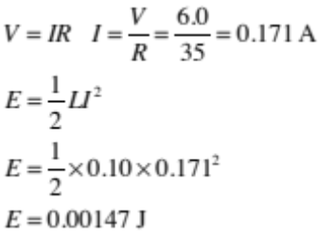 | - Correct current (0.171 A).  - Correct working for energy with incorrect current. | - Correct answer:  (1.47 × 10^{–3} J)  - 1.5 J  - 1.5 mJ

Q | Evidence | Achievement | Merit | Excellence
THREE  (a) | 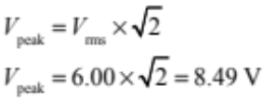 | Correct answer.
(b) | Iron in the core will increase the coil’s reactance.  Impedence = reactance + resistance  Increasing the reactance causes the impedance to increase.  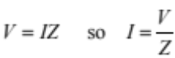  This causes the current to decrease (V is constant). | - X_{L} / L / Z increases. | - X_{L} / L and Z increases.
(c) | 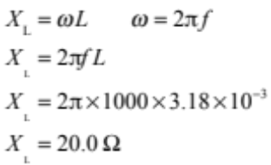  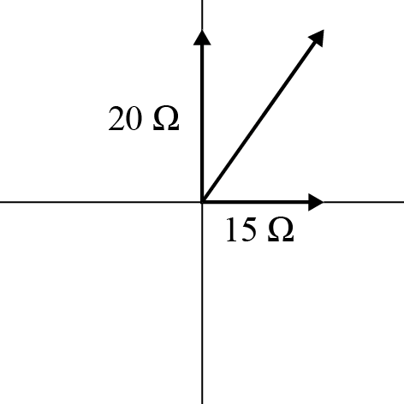  Resistance = 15.0 Ω  Reactance = 20.0 Ω  Impedance =  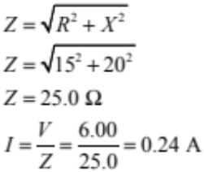 | - Correct phasor diagram with labels  - Correct inductor reactance  - Correct working for Z and I but uses L as X_{L} or f as ω | - One error | - Correct phasor diagram, and calculation of impedence AND current.  - I = 0.24 ( I = 0.212 A)
(d) | The voltages across the capacitor and inductor are out of phase (opposite direction), so partially (or totally) cancel out.  The supply voltage is constant. So the resistor voltage will increase and the current will increase. 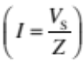  OR  The reactances of the inductor and capacitor are out of phase (opposite direction), so partially (or totally) cancel out.  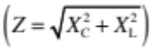  The supply voltage is constant, so the current will increase. | - Voltage or reactance phasors are out of phase, so partially cancel out.  - Impedance decreases, so current increases. (The supply voltage is constant.) | - Voltage or reactance phasors are out of phase, so partially cancel out.  AND  - Impedance decreases, so current increases. (The supply voltage is constant.)

Cut Scores
Not Achieved | Achievement | Achievement with Merit | Achievement with Excellence
0 – 6 | 7 – 14 | 15 – 18 | 19 – 24

